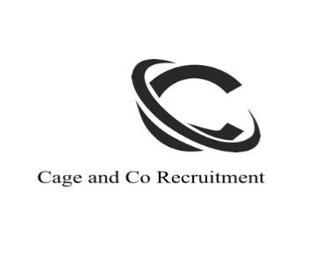YOUR LINKEDIN CHECKLIST
Your
Linkedin Profile enables you make connections, find jobs and Network LIKE NEVER before.

Take your JOB HUNTING into YOUR OWN HANDS.

LINKEDIN PROFILE CHECKLIST

☐

KEEP YOUR PROFILE CLEAR on what you can do.

☐

BE CLEAR on what you are looking for

☐

Create a PLAN on what you should POST

and connect with business pages and groups in

Your industry. This will help you to connect with people and work places you may

want to

Work in and increase your chances of being found.

☐

Create a PLAN on WHO you should NETWORK WITH

☐

Your Settings and TAGS should be relevant and completed

☐

Is Your Profile consistent with your Resume?

☐

Use an updated photo

☐

What is your Networking Message?

NETWORKING MESSAGE IDEAS
-

JOT THEM BELOW

☐

NETWORK PLAN- WHO WILL YOU CONNECT WITH? JOT YOUR IDEAS BELOW
☐

CAGE AND CO RECRUITMENT Linkedin CHECKLIST www.cageandcorecruitment.net

PROFILE PHOTO CHECKLIST

☐

Dress for your industry and look into the camera

☐

Have a solid
background or greenery.

☐

Do not have anyone else in the photo and make sure you have a current photo of yourself.

☐

Take the picture from the elbow up

☐

Use adequate lighting (Natural Lighting is best)

☐

I phone or quality phone camera.

“DO N
OT” POST SOCIAL POSTS ON LINKEDIN. REMEMBER THIS IS A
PROFESSIONAL FORUM FOR NETWORKING AND INCREASES YOUR
CHANCES OF GAINING EMPLOYMENT.

CAGE AND CO RECRUITMENT Linkedin CHECKLIST www.cageandcorecruitment.net

